Stephen Downs Garrison

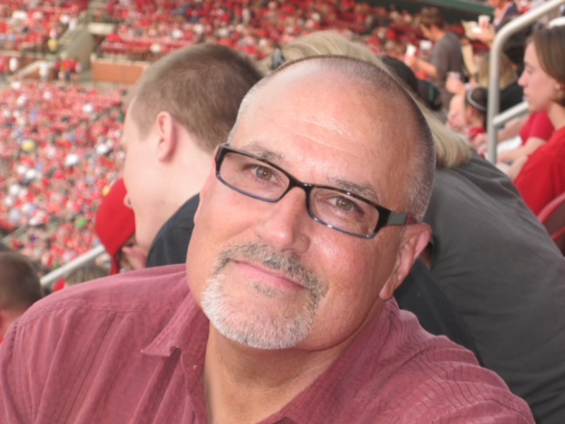

Stephen Downs Garrison, of Brevard, passed away on Thursday, February 23, 2023. He was 67 years old.

Steve was born on June 7, 1955 in Riverdale, Maryland to Carlton Garrison and Martha Lee Garrison. He grew up in Laurel. He was a 1973 graduate of Laurel Senior High School and lived in Maryland most of his life. He moved from Tennessee to Brevard, NC in 2019.

In his early life, Steve was a competitive athlete, involved in track in high school. He ran as part of Laurel High’s men’s relay teams and competed in individual events. He still holds state high school records to this day. As he grew older, he found a passion for cycling. He was part owner/operator of Proteus bike shop in College Park, Maryland. He earned several medals from USCF National Championships including those for tandem racing. Steve was an avid whitewater boater who enjoyed paddling big rivers across the country. He was a past president of the Canoe Cruisers Association. He enjoyed skiing and snowboarding and often took trips to Canaan Valley with his sons, as well as backcountry skiing trips out west.

In his professional life, Steve worked in sales and project management in the fire systems industry employed at Siemens in the Baltimore/DC/VA area for most of his career. After that he transitioned to Beacon Technologies in Nashville, TN. In his retirement he worked part time in the hardware department at Lowes in Brevard.

Steve had many passions in life. He enjoyed building and restoring old vehicles. His favorites included his 1951 Chevy, his 1962 Ford truck and his 1929 Ford Highboy. This last hotrod brought about numerous awards. It was the subject of a feature article in Street Rodder magazine in December 2010 when it was named to the Street Rodder magazine Top 100 list. His riding passion extended to motorcycles. He loved exploring twisty mountain roads and perfecting his skills at the track. His most treasured motorcycle experience was riding with friends in Europe, a trip completed in 2019. He rode locally with the Appalachian BMW Riders group on Wednesdays. He was an avid hiker and lover of the outdoors. He enjoyed music, photography, reading, building/designing model cars and dogs.

He is survived by his sons, Davis Garrison (partner Emily Del Balzo), Tyler Garrison (partner Jessica Erickson); his former wife and their son’s mother Kelley Donovan; siblings Kenn Garrison (Janet), Marilyn Garrison Eshoo (Denny), Linda Garrison Shearer (Chuck) and Janice Garrison Nicholas (Charles); many nieces and nephews and great nieces and great nephews; and his loving and devoted partner, Cheryl Manzone.

Donations in his memory may be made to WTMD Towson Radio, an NPR affiliate station broadcast from the campus of Towson University (<https://www.wtmd.org/radio/>), your local animal shelter or Humane Society, or the Dolly Sods Wilderness Stewards Program (<https://www.wvhighlands.org/about-the-dolly-sods-wilderness-stewards-program/>) an area in West Virginia that he loved greatly.

A time of remembrance and celebration of life will be held in Maryland at a later date. Condolences can be left at [www.jacksonfuneralservice.com](http://www.jacksonfuneralservice.com) or 1101 Greenville Highway, Hendersonville, NC 28792. Please place Mr. Garrison’s name on the outside of the envelope.